Prepare Multiple Nodes on Alibaba Cloud

1.1. Purchase Single Node on Alibaba Cloud
Step 1: Click https://homenew.console.aliyun.com/home/dashboard/ProductAndService, choose the ECS service,
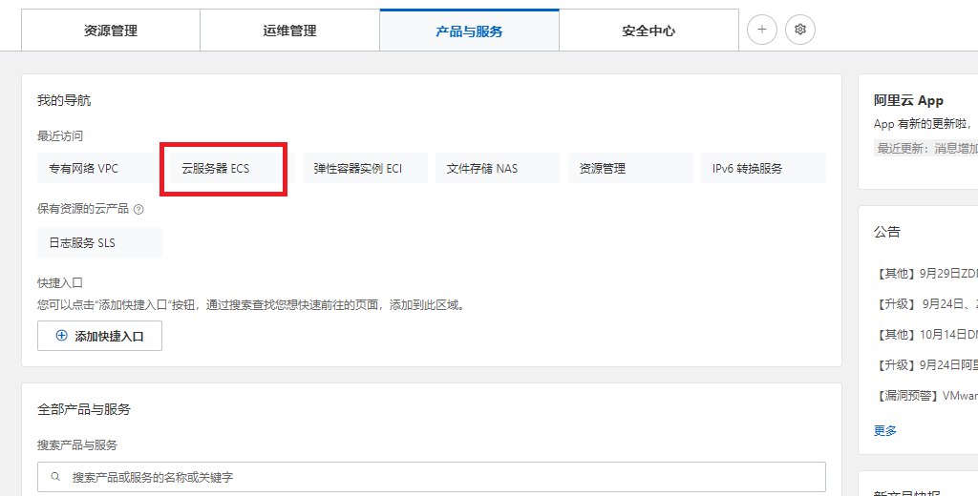
Step 2: Create a new instance, choose pay as you go, choose ecs.c7.2xlarge, choose Ubuntu 16.04 64 bits, choose ESSD, choose no IPv4 address, choose your password Y0urpassword,
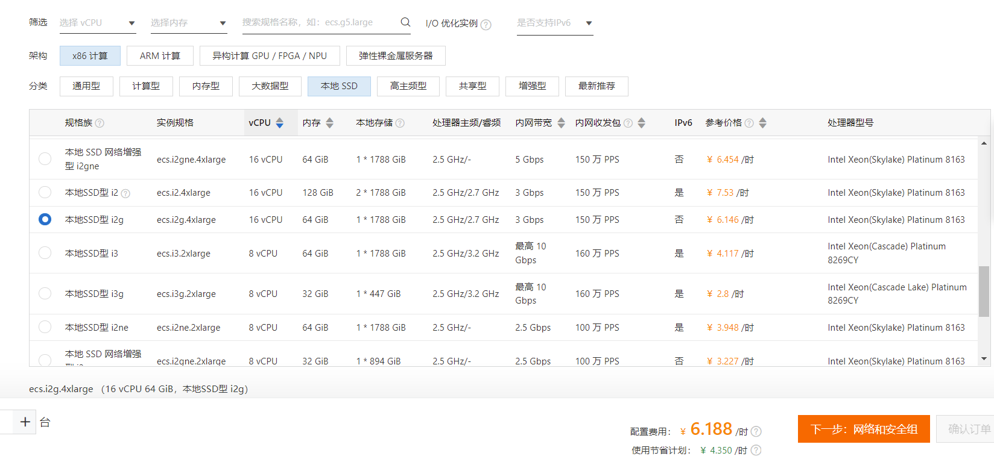
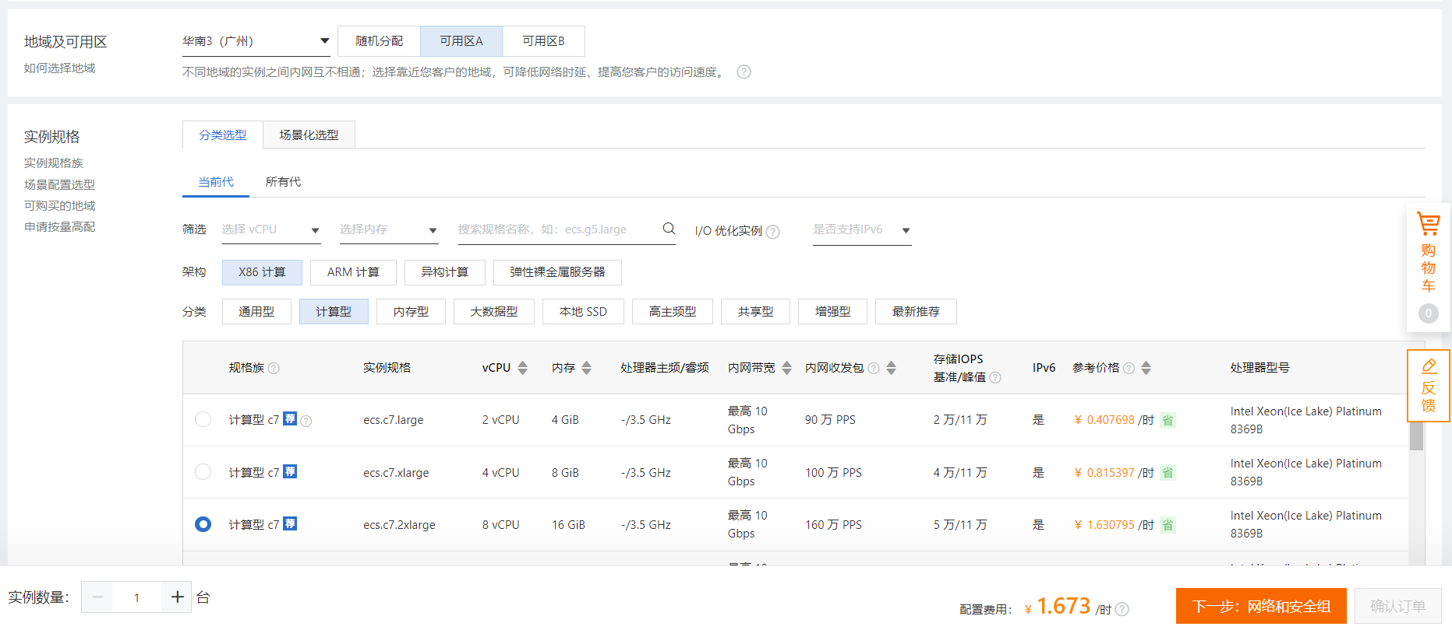
Step 3: Double-check the order,
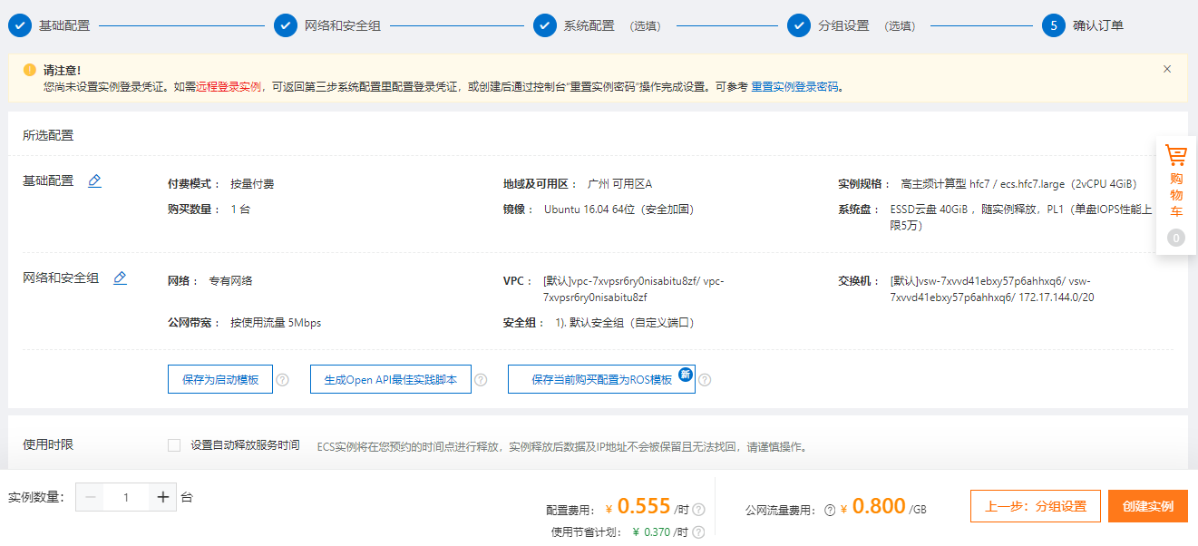

Step 4: Pay the order,
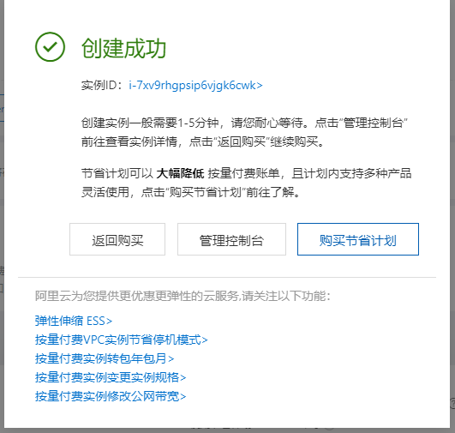
Step 5: Access the ECS instance via Alibaba Workbench, where the default username is root,
So far, the ECS instance cannot access the Internet because it has no IP address.

1.2. Purchase a NAT Gateway

Step 1: Click https://vpc.console.aliyun.com/nat/cn-guangzhou/nats, purchase 2 public IP addresses, create a NAT gateway,
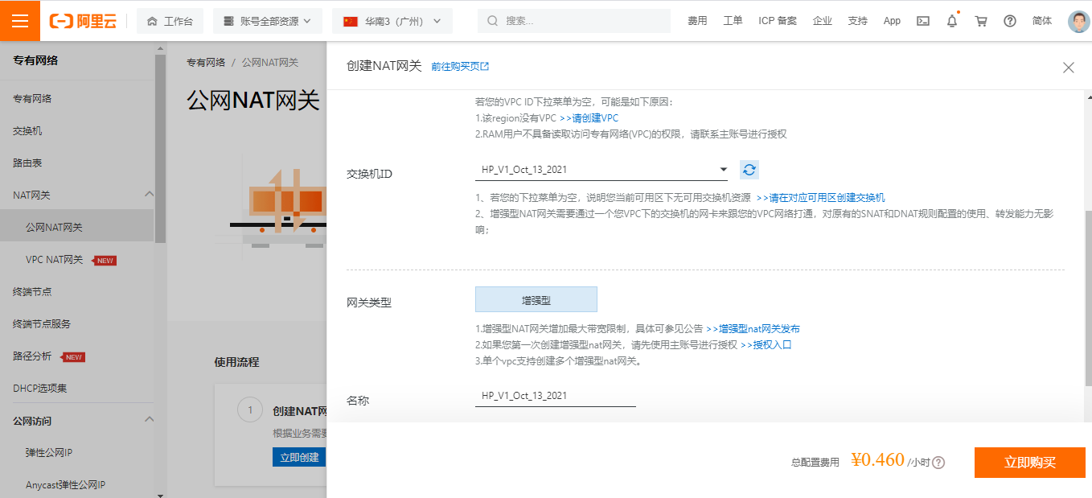

Step 2: After purchasing 2 public IP addresses, we have 8.163.56.8 and 8.138.164.210,
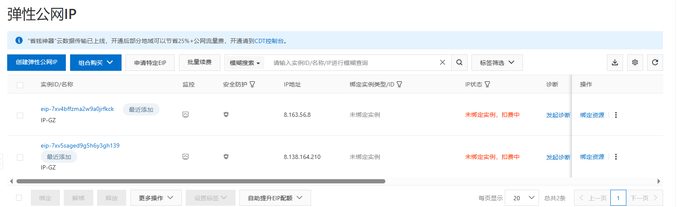

1.3. Purchase Multiple Node on Alibaba Cloud

Step 1: Click https://vpc.console.aliyun.com/vpc/cn-guangzhou/vpcs, purchase another 10 ECS nodes,
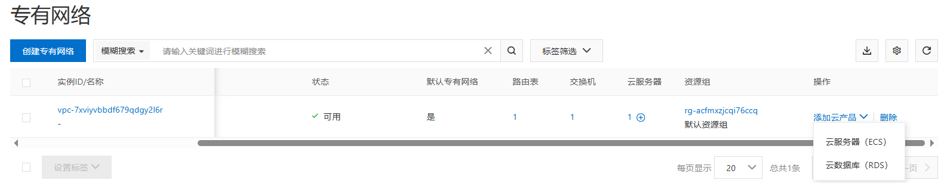

choose pay as you go, choose ecs.c7.2xlarge, choose Ubuntu 16.04 64 bits, choose ESSD, choose no IPv4 address, choose your password Y0urpassword,
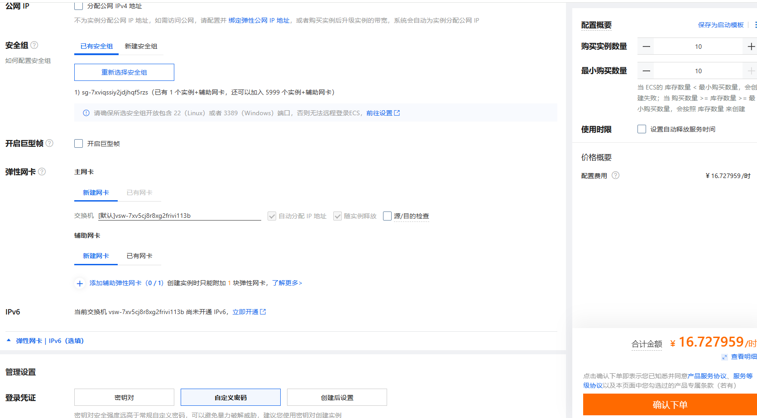

1.4. Configure the NAT Gateway

Step 1: Click https://vpc.console.aliyun.com/nat/cn-guangzhou/nats, configure the NAT gateway, where the IP address 8.163.56.8 for DNAT and 8.138.164.210 for SNAT (DNAT for Internet users and SNAT for VM inside). Currently, we have 1 NAT, 2 Public IP addresses, and 11 ECS, our target is as follows:
For NAT (Public IP):
SNAT | DNAT
8.138.164.210 | 8.163.56.8

For ECS maps (Inside IP):
SNAT | DNAT
- | 172.31.210.67
- | 172.31.210.70
- | 172.31.210.71
- | 172.31.210.72
- | 172.31.210.73
- | 172.31.210.74
- | 172.31.210.75
- | 172.31.210.76
- | 172.31.210.77
- | 172.31.210.78
- | 172.31.210.79

Step 2: Configure the SNAT,
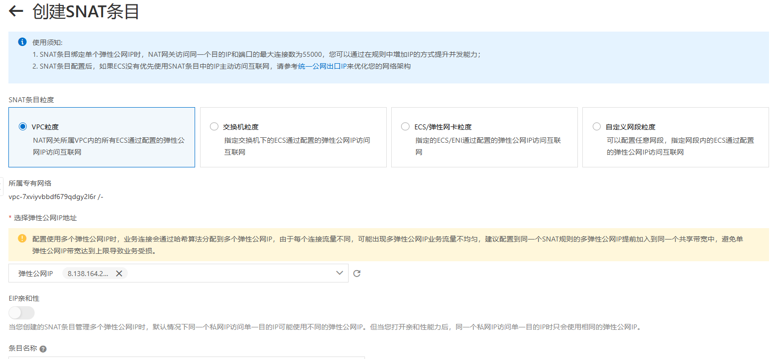

Step 3: Configure the DNAT,
ECS maps:
DNAT Public IP and Port Number | DNAT Inside IP
8.163.56.8:9999 | 172.31.210.67
8.163.56.8:10000 | 172.31.210.70
8.163.56.8:10001 | 172.31.210.71
8.163.56.8:10002 | 172.31.210.72
8.163.56.8:10003 | 172.31.210.73
8.163.56.8:10004 | 172.31.210.74
8.163.56.8:10005 | 172.31.210.75
8.163.56.8:10006 | 172.31.210.76
8.163.56.8:10007 | 172.31.210.77
8.163.56.8:10008 | 172.31.210.78
8.163.56.8:10009 | 172.31.210.79

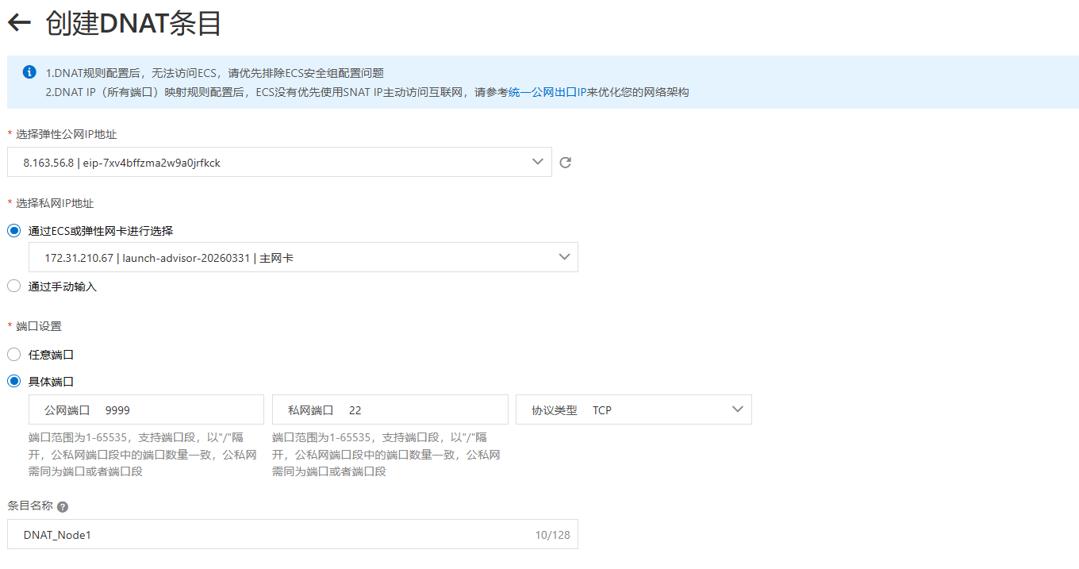
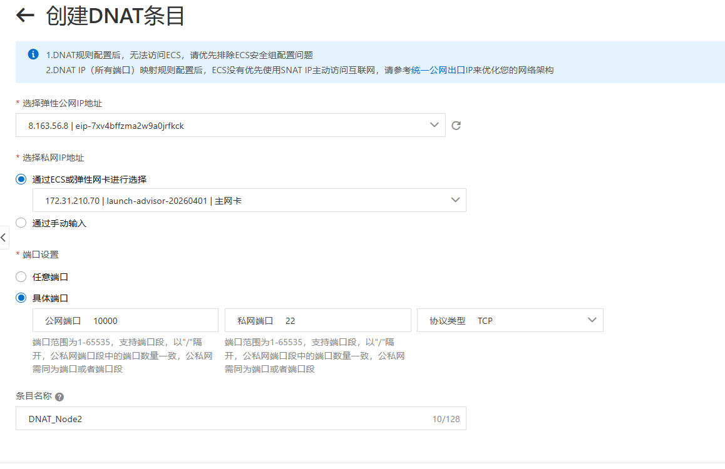
Access the inside IPs via Xshell,
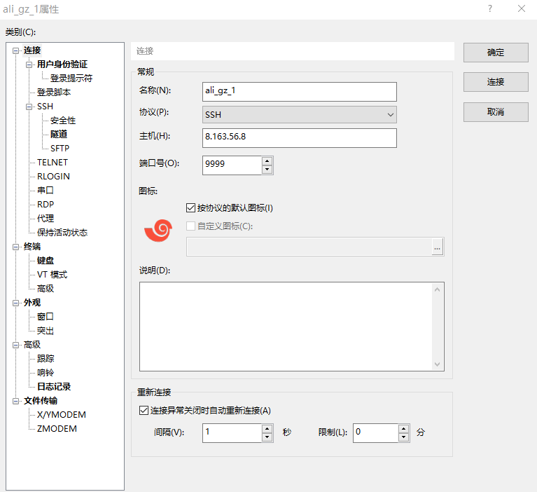
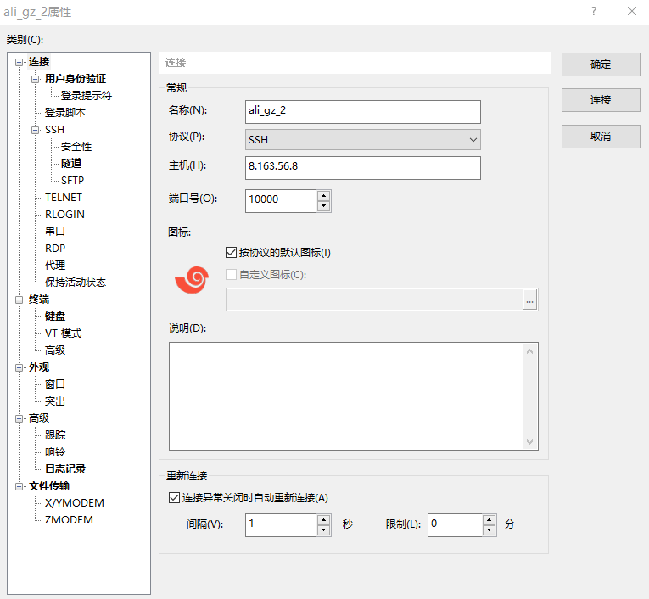

1.5. Configure the password-free SSH

Step 1: The target is as follows,
Host with free-password SSH to
172.31.210.67 | -
172.31.210.67 | 172.31.210.70
172.31.210.67 | 172.31.210.71
172.31.210.67 | 172.31.210.72
172.31.210.67 | 172.31.210.73
172.31.210.67 | 172.31.210.74
172.31.210.67 | 172.31.210.75
172.31.210.67 | 172.31.210.76
172.31.210.67 | 172.31.210.77
172.31.210.67 | 172.31.210.78
172.31.210.67 | 172.31.210.79

Step 2: Configure the 172.31.210.67,
$ ssh-keygen

$ ssh root@172.31.210.70 'mkdir -p .ssh && cat > .ssh/authorized_keys' < ~/.ssh/id_rsa.pub
$ ssh root@172.31.210.71 'mkdir -p .ssh && cat > .ssh/authorized_keys' < ~/.ssh/id_rsa.pub
$ ssh root@172.31.210.72 'mkdir -p .ssh && cat > .ssh/authorized_keys' < ~/.ssh/id_rsa.pub
$ ssh root@172.31.210.73 'mkdir -p .ssh && cat > .ssh/authorized_keys' < ~/.ssh/id_rsa.pub
$ ssh root@172.31.210.74 'mkdir -p .ssh && cat > .ssh/authorized_keys' < ~/.ssh/id_rsa.pub
$ ssh root@172.31.210.75 'mkdir -p .ssh && cat > .ssh/authorized_keys' < ~/.ssh/id_rsa.pub
$ ssh root@172.31.210.76 'mkdir -p .ssh && cat > .ssh/authorized_keys' < ~/.ssh/id_rsa.pub
$ ssh root@172.31.210.77 'mkdir -p .ssh && cat > .ssh/authorized_keys' < ~/.ssh/id_rsa.pub
$ ssh root@172.31.210.78 'mkdir -p .ssh && cat > .ssh/authorized_keys' < ~/.ssh/id_rsa.pub
$ ssh root@172.31.210.79 'mkdir -p .ssh && cat > .ssh/authorized_keys' < ~/.ssh/id_rsa.pub

$ ssh 172.31.210.70 "echo 'hi'"
$ ssh 172.31.210.71 "echo 'hi'"
$ ssh 172.31.210.72 "echo 'hi'"
$ ssh 172.31.210.73 "echo 'hi'"
$ ssh 172.31.210.74 "echo 'hi'"
$ ssh 172.31.210.75 "echo 'hi'"
$ ssh 172.31.210.76 "echo 'hi'"
$ ssh 172.31.210.77 "echo 'hi'"
$ ssh 172.31.210.78 "echo 'hi'"
$ ssh 172.31.210.79 "echo 'hi'"

1.6. Free the NAT Gateway
Step 1: Click https://vpc.console.aliyun.com/nat/cn-guangzhou/nats/ngw-7xv0l1e59yh41ve2vhc0g/snats, delete SNAT,
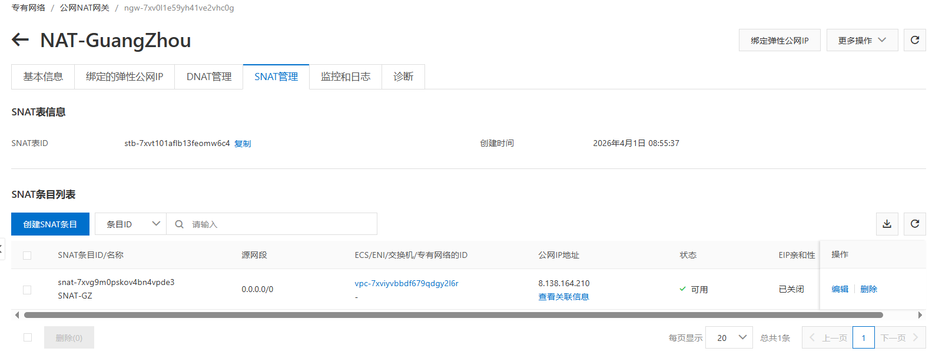
Step 2: Click https://vpc.console.aliyun.com/nat/cn-guangzhou/nats, unbind public IP, free public IP,
Step 3: Click https://homenew.console.aliyun.com/home/dashboard/ProductAndService, delete ECS,
Step 4: Click https://vpc.console.aliyun.com/nat/cn-guangzhou/nats, delete NAT

Prepare and Run Single Node Fabric Test-Network

2.1. Configure Each Node
Step 1: Configure the host names,
# sudo vi /etc/hosts
:set paste
I

172.31.210.67 peer0.org1.example.com

172.31.210.70 client1.peer
172.31.210.71 client2.peer
172.31.210.72 client3.peer
172.31.210.73 client4.peer
172.31.210.74 client5.peer
172.31.210.75 client6.peer
172.31.210.76 client7.peer

172.31.210.77 order.example.com
172.31.210.78 order2.example.com
172.31.210.79 order3.example.com

2.2. Install Dependencies on Each Node
Step 1: Install the prerequisites on each node,
// Prerequisite: Git
$ sudo apt-get update
$ sudo apt purge -y git
$ sudo apt-get install -y git // =1:2.7.4-0ubuntu1.9
$ git version // 2.7.4
$ export PATH=$PATH:/usr/lib/git-core
$ echo 'export PATH=$PATH:/usr/lib/git-core' >> ~/.bashrc
$ source ~/.bashrc

Step 2: Install the cURL on each node,
// Prerequisite: cURL
$ sudo apt-get install -y curl
$ curl –version // 7.47.0

Step 3: Install the wget on each node,
// Prerequisite: wget
$ sudo apt-get install -y wget=1.17.1-1ubuntu1.5

Step 4: Install Docker on each node,
// Prerequisite: Docker 17.06.2-ce or greater: Docker 17.12.0-ce
$ sudo apt-get purge -y docker-ce docker-ce-cli
$ wget https://download.docker.com/linux/ubuntu/gpg
$ sudo apt-key add gpg
$ echo 'deb [arch=amd64] https://download.docker.com/linux/ubuntu xenial stable' | sudo tee /etc/apt/sources.list.d/docker.list
$ sudo apt-get update
$ apt-cache madison docker-ce
$ sudo apt-get install docker-ce=17.12.0~ce-0~ubuntu
$ sudo usermod -aG docker $USER
$ docker version

Step 5 (if outside the Great Wall): Install Docker Compose on each node,
// Prerequisite: Docker Compose 1.14.0 or greater: 1.21.0
$ sudo apt-get purge -y docker-compose
$ sudo curl -L https://github.com/docker/compose/releases/download/1.21.0/docker-compose-`uname -s`-`uname -m` -o /usr/local/bin/docker-compose
$ sudo chmod +x /usr/local/bin/docker-compose
$ docker-compose version

Step 5 (if within the Great Wall): Install Docker Compose on each node,
// Prerequisite: Docker Compose 1.14.0 or greater: 1.21.0
$ sudo apt-get purge -y docker-compose
$ mkdir downloads
$ cd $HOME/downloads
$ wget https://gitee.com/joe32065/fabric_2_2/releases/download/fabric-v2.2.0/docker-compose
$ sudo chmod +x docker-compose
$ sudo mv docker-compose /usr/local/bin
$ docker-compose version

Step 6 (if outside the Great Wall): Install Golang on each node,
// Prerequisite: Go v1.14.8
$ cd $HOME/downloads
$ wget https://golang.org/dl/go1.14.8.linux-amd64.tar.gz
$ tar -xzf go1.14.8.linux-amd64.tar.gz
$ sudo rm -rf /usr/local/go
$ sudo mv go /usr/local
$ mkdir -p $HOME/go
$ echo 'export PATH=$PATH:/usr/local/go/bin' >> ~/.bashrc
$ echo 'export GOPATH=$HOME/go' >> ~/.bashrc
$ source ~/.bashrc
$ go version // go1.14.8 linux/amd64

Step 6 (if within the Great Wall): Install the Golang on each node,
// Prerequisite: Go v1.14.8
$ cd $HOME/downloads
$ … // download go1.14.8.linux-amd64.tar.gz on node one, e.g., via winscp,
$ scp go1.14.8.linux-amd64.tar.gz root@172.31.210.70:$HOME/downloads
$ scp go1.14.8.linux-amd64.tar.gz root@172.31.210.71:$HOME/downloads
$ …
$ scp go1.14.8.linux-amd64.tar.gz root@172.31.210.79:$HOME/downloads

$ tar -xzf go1.14.8.linux-amd64.tar.gz
$ sudo mv go /usr/local
$ mkdir -p $HOME/go
$ echo 'export PATH=$PATH:/usr/local/go/bin' >> ~/.bashrc
$ echo 'export GOPATH=$HOME/go' >> ~/.bashrc
$ source ~/.bashrc
$ go version // go1.14.8 linux/amd64

Step 7: Install Node.js on each node,
// Prerequisite: Node.js v12.20.1 or higher
$ cd $HOME/downloads
$ curl -sL https://deb.nodesource.com/setup_12.x -o nodesource_setup.sh
$ sudo chmod +x nodesource_setup.sh
$ sudo bash nodesource_setup.sh
$ sudo apt-get install -y nodejs --allow-unauthenticated
$ nodejs -v // v12.22.12

$ curl -o- https://raw.githubusercontent.com/nvm-sh/nvm/v0.35.3/install.sh | bash
$ // close the terminals, and open the terminals again
$ cd $HOME/downloads
$ sudo npm -g install nvm
$ nvm ls available
$ nvm install 12.20.1
$ nvm use 12.20.1

Step 8: Install the NTP on each node,
$ sudo apt-get install ntp
$ sudo service ntp start

2.3. Install Fabric 2.2.0

Step 1 (if outside the Great Wall): Install Fabric 2.2.0, including Fabric Samples on each node,
$ cd $HOME
$ sudo rm -rf fabric-samples
$ curl -sSL https://bit.ly/2ysbOFE | bash -s -- 2.2.0

Step 1 (if within the Great Wall): Install Fabric 2.2.0, including Fabric Samples on each node,
$ cd $HOME
$ sudo rm -rf fabric-samples
$ sudo apt-get install unzip
$ cd $HOME
$ wget https://gitee.com/joe32065/fabric_2_2/releases/download/fabric-v2.2.0/fabric-v2.2.0.zip
$ unzip fabric-v2.2.0.zip
$ cd fabric-v2.2.0/scripts

In bootstrap.sh -> ”pullBinaries()”，
download "${BINARY_FILE}" "https://github.com/hyperledger/fabric/releases/download/v${VERSION}/${BINARY_FILE}"
download "${CA_BINARY_FILE}" "https://github.com/hyperledger/fabric-ca/releases/download/v${CA_VERSION}/${CA_BINARY_FILE}"

Replace with the two lines，
download "${BINARY_FILE}" "https://gitee.com/joe320653/fabric/attach_files/842230/download/${BINARY_FILE}"
download "${CA_BINARY_FILE}" "https://gitee.com/joe320653/fabric-ca/attach_files/842289/download/${CA_BINARY_FILE}"

In bootstrap.sh -> ” cloneSamplesRepo()”，
git clone -b master https://github.com/hyperledger/fabric-samples.git && cd fabric-samples && git checkout v${VERSION}

Replace with the two lines,
git clone -b master https://gitee.com/joe320653/fabric-samples.git && cd fabric-samples && git checkout v${VERSION}

Step 2: Install docker images and fabric-samples on each node,
$ cd $HOME/fabric-v2.2.0/scripts
$ chmod 777 *.sh

$ // configure the docker container service within the Great Wall
$ cd $HOME
$ sudo mkdir -p /etc/docker
$ sudo tee /etc/docker/daemon.json <<-'EOF'
{
"registry-mirrors": ["https://2htzxp9d.mirror.aliyuncs.com"]
}
EOF
$ sudo systemctl daemon-reload
$ sudo systemctl restart docker

$ cd $HOME/fabric-v2.2.0/scripts
$ sudo ./bootstrap.sh
$ mv fabric-samples $HOME

2.4. Run Test-Network

Step 1 (if outside the Great Wall): Run test network on each node,
$ cd $HOME/fabric-samples/test-network
$ ./network.sh up
$ ./network.sh createChannel
$ ./network.sh deployCC -ccn basic -ccp ../asset-transfer-basic/chaincode-go -ccl go
$ ./network.sh down

The success information is as follows,
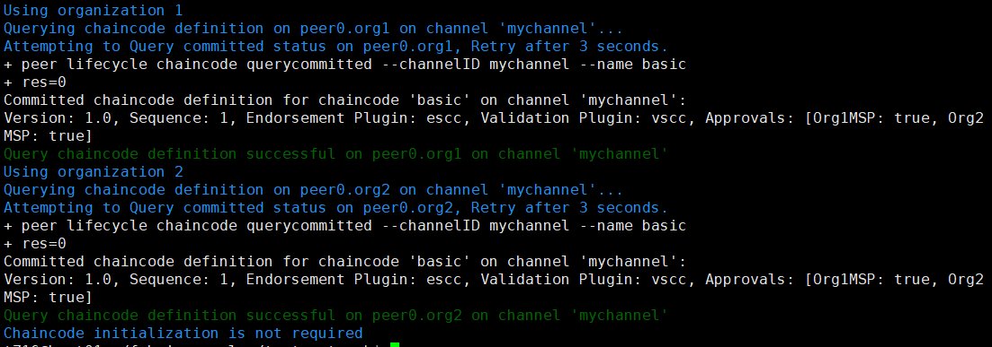

Step 1 (if within the Great Wall): Run test network on each node,
Set the Golang Proxy,
$ go env -w GOPROXY=https://goproxy.cn

Run the test network,
$ cd $HOME/fabric-samples/test-network
$ ./network.sh up
$ ./network.sh createChannel
$ ./network.sh deployCC -ccn basic -ccp ../asset-transfer-basic/chaincode-go -ccl go
$ ./network.sh down

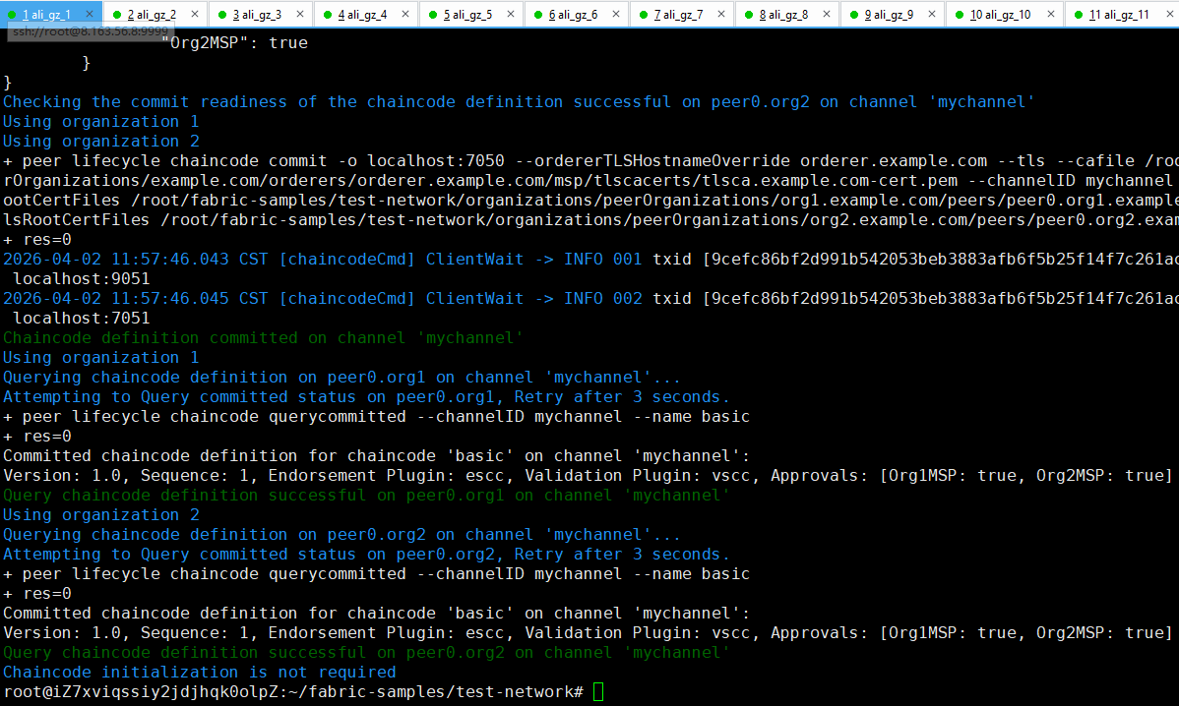

3. Prepare and Run Multiple Nodes on Fabric 2.2.0 (1 CLI + 2 Peers + 1 Orderer)

3.1. Prepare the Hosts

Step 1 (Prepare): All machines prepare the host names,
$ vi /etc/hosts

# 172.31.210.67 cli (of peer0.org1)
172.31.210.70 peer0.org1.example.com
172.31.210.71 peer0.org2.example.com
172.31.210.72 orderer.example.com

Step 2 (Prepare): CLI prepares the Test-Network files,
$ cd $HOME/fabric-samples
$ mkdir demo-first
$ cd $HOME/fabric-samples/demo-first
$ vi crypto-config.yaml
$ vi configtx.yaml

$ vi peer0-org1.yaml
$ vi peer0-org2.yaml

$ vi orderer1.yaml

$ vi cli.yaml // (of peer0.org1)

$ vi $HOME/fabric-samples/chaincode/abstore/go/abstore.go // our proposed key-value chaincode
$ vi $HOME/fabric-samples/chaincode/abstore/go/go.mod

Step 2 (Prepare): All machines prepare the timestamp alignment,
$ date +%s // check the timestamp

$ sudo apt-get install ntpdate // align the timestamp
$ sudo ntpdate cn.pool.ntp.org
$ sudo hwclock –systohc

$ date +%s // check the timestamp again

Step 3 (Run): CLI runs the initial block generation,
$ cd $HOME/fabric-samples/demo-first
$ chmod +x *.sh
$ ./config.sh

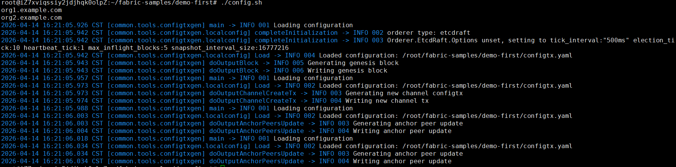

$ cd $HOME/fabric-samples/demo-first/workload/tls
$ chmod +x *.sh

$ cd $HOME/fabric-samples/demo-first/workload
$ chmod +x *.sh
$ wget https://gitee.com/joe32065/fabric_2_2/releases/download/fabric-v2.2.0/node_modules.zip
$ unzip node_modules.zip

$ cd $HOME/fabric-samples/demo-first/scripts
$ chmod +x *.sh

Step 4 (Run): CLI scp the contents to all machines including peers and orderers,
$ cd $HOME/fabric-samples/demo-first
$ ./scp.sh

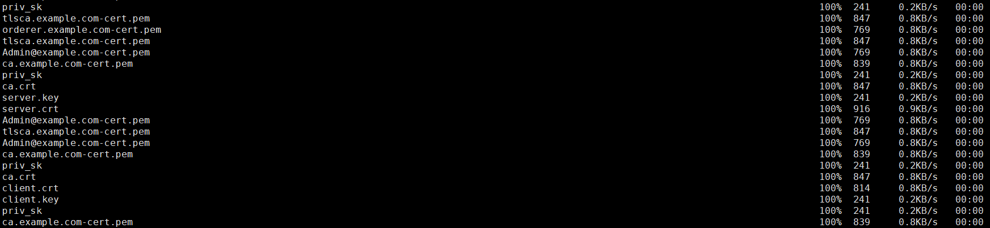

Step 5 (Run): Orderer1 sets up the Docker container,
$ cd $HOME/fabric-samples/demo-first
$ ./orderer1.sh

$ docker ps

Step 6 (Run): Peer1 sets up the Docker container,
$ cd $HOME/fabric-samples/demo-first
$ ./peer1.sh

$ docker ps

Step 7 (Run): Peer2 setups the docker container,
$ cd $HOME/fabric-samples/demo-first
$ ./peer2.sh

$ docker ps

Step 8 (Run): CLI setups the docker container,
$ cd $HOME/fabric-samples/demo-first
$ ./cli.sh

$ docker ps

3.2. Start the Network

Step 1 (Run): CLI (of peer0.org1) connects to Peer0.org1.example.com:7051, creates a channel.block, and then all peers join the channel.block,
// CLI goes to `peer0.org1.example.com:7051`
$ docker exec -it cli bash

// Environment Configuration for `peer0.org1.example.com:7051`
# cd scripts
# ./step1.sh // All peers join the channel

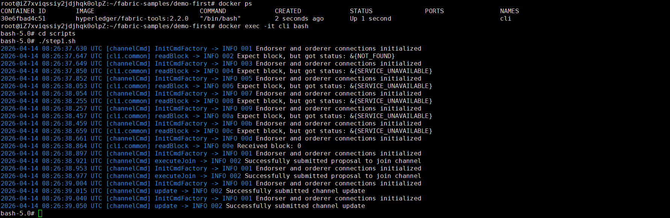

# ./step2.sh // All peers join the chaincode

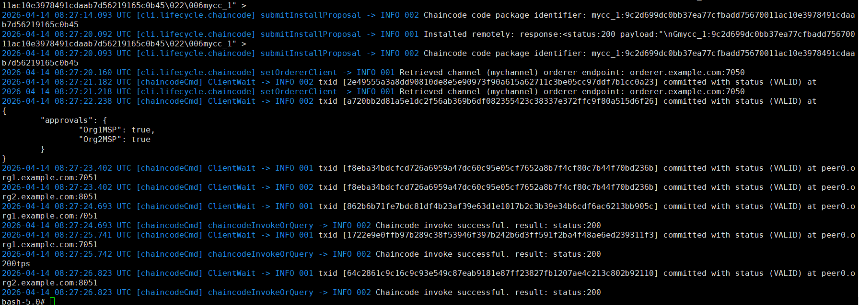

3.4. Start Nodejs SDK

Step 1 (Run): CLI configures the Nodejs SDK folder and tls, wallet, and workload files for all peers,
# exit
$ mkdir -p $HOME/fabric-samples/demo-first/workload
$ mkdir -p $HOME/fabric-samples/demo-first/workload/tls
$ mkdir -p $HOME/fabric-samples/demo-first/workload/wallet
$ mkdir -p $HOME/fabric-samples/demo-first/workload/result

$ cd $HOME/fabric-samples/demo-first/workload/tls
$ vi read_pem.py
$ vi prepare_tls_peer0_org1.sh
$ vi prepare_tls_peer0_org2.sh
$ ./all.sh

$ cd $HOME/fabric-samples/demo-first/workload/wallet
$ vi prepare_wallet_user1_org1.py
$ vi prepare_wallet_user1_org2.py
$ ./all.sh

$ cd $HOME/fabric-samples/demo-first/workload
$ mkdir sdk-peer0-org1
$ mkdir sdk-peer0-org2
$ vi invoke.js
$ vi prepare_sdk_peer0_org1.sh
$ vi prepare_sdk_peer0_org2.sh
$ ./all.sh

Step 2: Prepare the Nodejs SDK dependencies on CLI,
$ cd $HOME/fabric-samples/demo-first/workload
$ vi package.json
$ npm install
$ vi $HOME/fabric-samples/demo-first/workload/node_modules/fabric-network/lib/transaction.js

Step 3: Prepare wallets of User1@org1.example.com and User1@org1.example.com on CLI,
$ cd $HOME/fabric-samples/demo-first/workload/wallet
$ rm -rf *.id
$ python prepare_wallet_user1_org1.py
$ python prepare_wallet_user1_org2.py
$ ./all.sh

Step 4: Nodejs invoke and query transactions on CLI,
$ cd $HOME/fabric-samples/demo-first/workload
$ ./scp.sh // CLI copies files to all machines

$ ./ssh.sh > result/benchlog
$ ls result -l
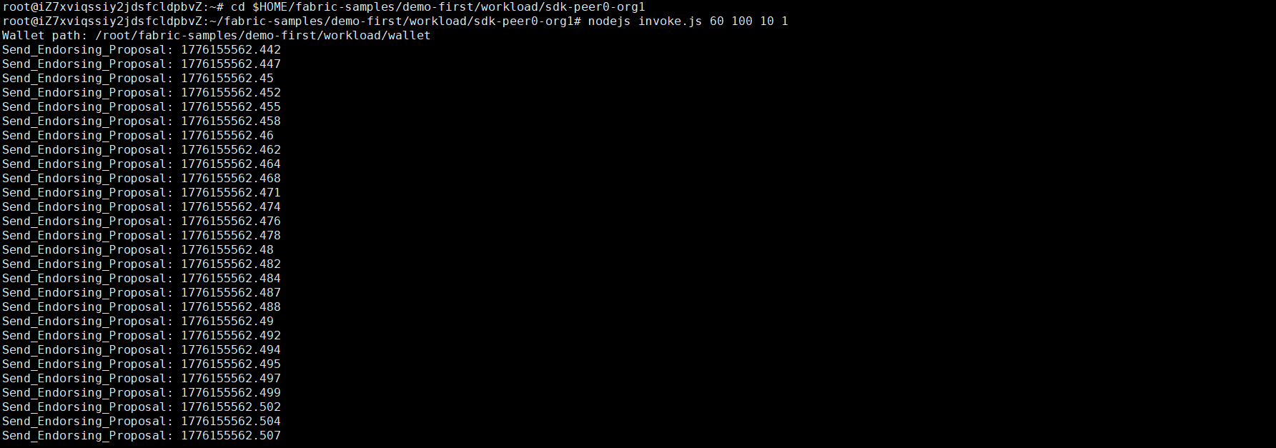

// $ node query.js
// $ node invoke.js 30 500 20 1

Step 5: Analyze the log,
$ cd $HOME/fabric-samples/demo-first/workload/result
$ python readthroughput_p1.py // rate of sending endorsed txs
$ python readdelay_p1.py // delay of endorsing phase

$ cd $HOME/fabric-samples/demo-first/workload/result
//$ docker logs containername >& ordererlog
$ docker logs $(docker ps -a | grep 'orderer'| awk '{print $1 }') >& ordererlog
// $ scp ordererlog chwang@1xx.1xx.7xx.1xx:/home/chwang
$ python readthroughput_p2.py // rate of generating blocks

$ cd $HOME/fabric-samples/demo-first/workload/result
//$ docker logs containername >& peerlog
$ docker logs $(docker ps -a | grep 'peer node start'| awk '{print $1 }') >& peerlog
// $ scp peerlog chwang@1xx.1xx.7xx.1xx:/home/chwang
$ python2 readthroughput_p3.py

// Get block size
# peer channel fetch 228 last.block -o orderer.example.com:7050 -c mychannel --tls --cafile /opt/gopath/src/github.com/hyperledger/fabric/peer/crypto/ordererOrganizations/example.com/orderers/orderer.example.com/msp/tlscacerts/tlsca.example.com-cert.pem

$ rm -rf benchlog
$ rm -rf ordererlog
$ rm -rf peerlog

Install the analysis tools,
$ sudo apt install python-numpy

Step 6: Clean,
# exit
$ cd $HOME/fabric-samples/demo-first
$ ./clean.sh

